**Residential Course Leader Pack**

This pack is designed to provide you with information to support you with planning your residential visit to us.

For further support, you can contact the centre to discuss your visit by phone or email.

01248 714501

[Jade.smith@edsential.co.uk](mailto:Jade.smith@edsential.co.uk)

[Gwawr.jones@edsential.co.uk](mailto:Gwawr.jones@edsential.co.uk)





**Welcome**

We look forward to welcoming you to our Conway Centre locations across England and Wales and sharing your residential experience with you. We know planning a residential experience can be a daunting task and we want to reassure you that we’re here to support you through the journey. Now you’ve confirmed your booking with us there are a few key thigs to consider before going any further.

**Insurance** – we strongly recommend you have comprehensive insurance in place to cover your residential visit with us, including cover for cancellation fees should you regrettably need to cancel for any reason. The Conway Centres **DO NOT** provide personal accident or cancellation insurance for visiting groups.

**Risk Assessments** - Before undertaking any visits, groups/schools and colleges are legally required to carry out a suitable and sufficient Risk assessment in accordance with *Management and Safety at Work Regulations 1999.* This should determine if preventative and protective measures (including emergency arrangements) are adequate and to record your findings about any significant risks.

Group Leaders have a duty of care towards pupils/participants and so in an activity where such risks are present, you will need to show that you have considered them and taken all reasonably practicable precautions. We welcome all groups to book a preview visit to see the site and discuss your visit.

These risk assessments will need to include:

* The journey to and from the centre, including any stops along the way.
* Management of your students/individuals within your accommodation and around centre
* Any self-led activities that are delivered by your staff members along with any free time activities. You can seek advice from an EVC Officer.

You **WILL NOT** need to Risk Assess any activities delivered by the Centre.

**Your visit will need to be approved by your EVC/Evolve or local authority equivalent.**

If your school/group need advice on getting your trip authorised or assistance with risk-assessments, you can find a local Educational Visits Coordinator on the Outdoor Education Advisors’ Panel website.

[**https://oeapng.info/oeap-advisers-in-england/**](https://oeapng.info/oeap-advisers-in-england/)

**<https://oeapng.info/oeap-advisers-in-wales/>**

**Supervision of Children and Young People** - Visiting staff who bring groups to the Conway Centres always hold and maintain overall responsibility for the supervision and welfare of their pupils/participants at all times and *are in loco parentis.* A member of Centre staff can be called upon to help with emergencies if necessary. We do require that all accompanying/support staff attending the residential hold a current valid DBS.

All accomodation has a security system in place to monitor anyone entering or leaving your accomodation. All alarms are simple and can be activated and de-activated by you. This will be explained during your induction on arrival at the centre.

**Safeguarding & Child Protection** -Conway Centres follows the Child Protection Policy of Edsential, the full policy can be provided upon request. All Conway Centre staff are required to undertake an enhanced DBS check as part of our recruitment process. We do also require all visiting staff hold a valid DBS. We expect all our staff to wear their identifiable staff badge around centre and would kindly ask that all your accompanying staff do the same while in residence. All visitors must sign-in and receive a visitors badge upon arrival at all our sites.

<https://edsential.com/leadership/safeguarding/>

Security

Our sites are very secure, all have electronic door systems that require a badge (Conway Staff) or personalised access code to gain entry. Your group will be provided with your own personalised access code for your stay.

Social Rooms /

Workspaces

All groups will have a social room with seating and drinks facilities allocated to them. We also have many workspaces available that can be allocated upon request if available.

Itinerary

You will receive a full programme and itinerary prior to arrival. Your programme will be planed around your aims/objectives, group age and ability.

Meals

All meals are provided, first meal being evening meal on arrival day, last meal lunch on departure day. All dietaries can be catered for if we are made aware in advance. You will have a set mealtime.

Accommodation

Accommodation is allocated based on a group’s size/numbers and needs. We will confirm your allocated accommodation once we receive your final numbers and have considered the needs of all groups on centre.

**Purpose/Aims & Objectives**

All visits should have an aim or purpose, whether it be team building, personal development or simply adventure. By sharing these aims with us we can develop your programme with these aims in mind to help support these learning objectives. We have a huge variety of activities that can support an array of learning opportunities and objectives, we will aim plan your programme based on the learning objectives you’re looking to achieve, while taking the age and ability of the group into consideration.

**Numbers Attending – Students & Staff**

During the booking process you would have received and signed a Booking Confirmation Agreement to secure your booking, this would have been followed by a Sales Order. We appreciate that groups book their visit in advance and therefore numbers attending may have been estimates at the time of booking. You will need to inform the Centre of accurate numbers **120 Days** before your visit to ensure that we can plan accordingly. At 120 days prior to your arrival date, we will issue your balance invoice based on the attending numbers we have on record. If you have been in touch to update us of any number changes this may be taken into account, otherwise the numbers we’re planning to will still be the same as the number of places secured at booking stage.

When updating us with your student numbers, we will also require the final number of staff you intent to bring with you for your visit. The number of staff/supporting adults you require to support your residential experience may vary depending on the ages/needs of your students or any specific guidance set by your school. All schools will receive 1 staff place free of charge for every 10 students attending.

Please advise us of your aims & objectives, along with student & staff numbers by completing the Course Details Form in Appendix 1 . Likewise you can also call or email us to advise us of these details.

**Accommodation / Room Lists / PEEP**

At point of booking your group will provisionally be allocated your accommodation, this is provisionally allocated based on your groups numbers and the accommodation building we have available. This provisional allocation of accommodation may be revised by the Conway Centre at any time to meet the overall operational needs of the site and all groups due to be in residence. Once we receive your final students/staff numbers (120 days prior to arrival) we will then be able to confirm your allocated accommodation for you and will send you an accommodation plan and rooms lists to be completed. Most student accommodation is dorm style with a combination of bunkbeds and single beds. All staff accommodation will be either a twin room or single room.

To allow time between change overs, access to rooms on arrival days will only be permitted once our housekeeping teams have left the area. All bedding is provided and beds must be made by students and staff once access is permitted to rooms. Beds will also need to be stripped by students and staff at the end of your stay and laundry placed in sacks provided. It is essential that all beds being used are made up for health a hygiene reason. We appreciate the support of visiting staff to ensure all students have made their bed.

***As access to rooms may not be until late afternoon, we strongly advise that all students partaking in afternoon activities arrive dressed ready for those activities so they do not need to change on arrival.***

**Room Lists** – We will provide you with room lists suitable for your allocated accommodation and request these room lists are completed and returned to us **60 days (8 weeks)** prior to your arrival. It is the responsibility of the course leader to ensure the rooms lists remain up to date at all times.

Room lists must include the room number, full name of all individuals in that room and adult responsible for that room in the event of an emergency. ***(Room list template can be located in Appendix 3).***

**PEEP (Personal Emergency Evacuation Plan)** – If any of your group require assistant evacuating a building in the event of an emergency, then a PEEP will need to be completed. A PEEP needs to be completed for each individual requiring assistance. Once we know the needs of your students we will assess if you require any additional facilities/resources while in residence with us. Primary we will try to ensure your allocated accommodation has the facilities/space you require, any additional resources will only be allocated once we know the needs of all groups due to be in residence at the same time. Any additional resources will then be allocated on a fair and measured basis, taking into consideration the needs of all groups in residence. ***(PEEP Form is located in Appendix 2)***

Please do note that in the event of a fire alarm or emergency, the visiting course leader and support staff are responsible for ensuring that all your group have been evacuated and accounted for. You will be shown the location of the fire assembly point on your site tour and induction to the centre.

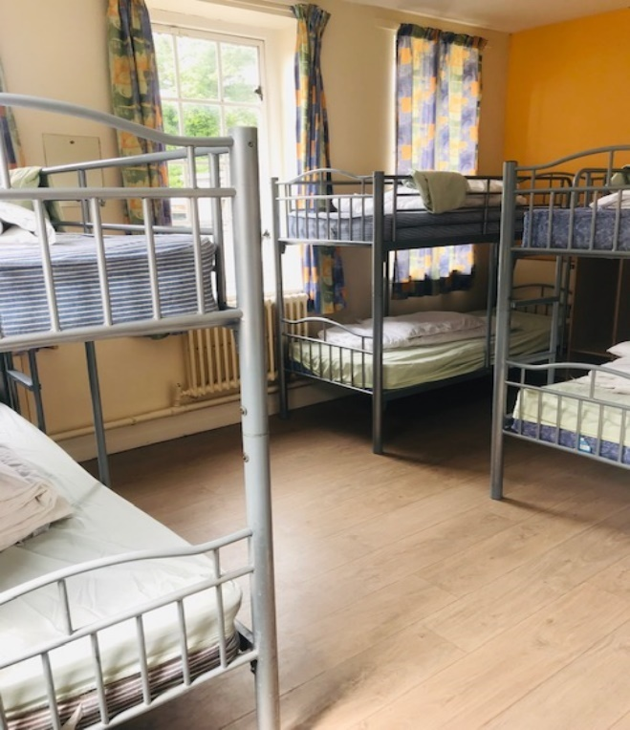 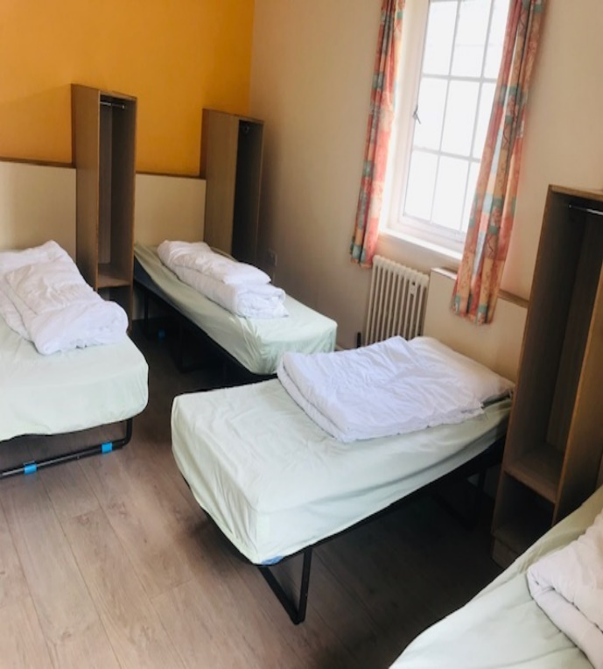

Examples of Typical Student Dorms

**Group Lists /Medical Details**

It is vital during your visit that we know exactly who and where all individuals are at all times, we will therefore ask you to complete activity lists to identify who will be partaking in what activities at any set time. There will need to be at least one school staff member with each activity group while on activity. We would ask you to return these lists to us **60 days (8 Weeks)** prior to your arrival.

For our qualified staff to make our activities as safe and inclusive as possible, we also require that you identify all medical, allergy and dietary information for individuals. For discretion and GDPR purposes we have created a coded system, we ask that you please support us in using this coding system. ***(Group List template and Medical Condition Key Code is located in Appendix 4)***

**Dietary Details**

To assist us in providing the best service we can for your stay, we ask you to provide us with any/all dietary details for all members for your groups, individuals and staff. Our catering team can cater for all general dietary needs if we are informed of them in advance, again we request you provide us with this information **60 days (8 Weeks)** prior to your arrival. During your stay there may be days where a packed lunch is required instead of a cooked lunch, we will detail this on your programme for you. If you wish to amend any packed lunch/cooked lunch choices, we must be informed of your request at the earliest convenience to be able to make this adjustment. We cannot guarantee any last minute requests may be obliged.

We aim to provide healthy balanced meal options and are the world’s first certified sustainable palm-oil catering company. At each meal there is usually at least 2-3 options to choose from along with a vegetarian option. There is always a mixed salad bar and selection of fresh fruit on offer with bread rolls to accompany main meals. There is a sample menu provided in appendix 6. ***(Group Dietary Needs Form located in Appendix 5)***

|  |  |  |
| --- | --- | --- |
| **Breakfast** | **Lunch** | **Evening Meal** |
| Fruit Juice  Choice of Cereals  Bacon, Sausage, Scrambled Egg, Baked Beans and, Hash Brown  Selection of Yoghurts and Fresh Fruit  Croissant /Toast with Jam or Marmalade | Jacket Potato with a selection of hot & cold fillings  Baguette with a selection of fillings  Selection of Salads  Selection of Desserts  **OR**  Packed Lunch | Sausage, Mash and Yorkshire Pudding with Gravy  (Vegetarian/vegan option available)  Variety of Pizza  Cheese and Onion Pie  Potato Wedges  Selection of Salads  Selection of Desserts |
| *\*\*Same as Above\*\** | *\*\*Same as Above\*\** | Pasta Bolognese with garlic bread  (vegetarian option available)  Spanish Chicken  Chickpea and Lentil Curry with rice.  Selection of Salads  Selection of Desserts |
| *\*\*Same as Above\*\** | *\*\*Same as Above\*\** | Chicken Curry, Rice and Naan  (Vegetarian option available)  Tomato & Basil Pasta  Selection of Salads  Selection of Desserts |

Sample Menu Extract

**Arrival**

Arrival is generally *no earlier than 11.00am to centre* if the group is to take part in afternoon activities delivered by Conway Centre Staff. When you arrive, you will be met by a Conway Centres staff member who will direct you off your coach and to an area where you can drop your bags. If this staff member is not visibly waiting you please report to reception or a Conway Centre staff member, we ask that you refrain from wandering the grounds for your own safety. Once your bags are dropped, they will proceed to give you a site tour and general H&S induction to the centre. We ask that you arrive no earlier than 11.00am as there will still be departing groups on centre and we may not have anywhere suitable for you to wait until your staff member is ready and available to induct you.

After you have been inducted and familiarised with the centre, you will be shown to an area where you can eat the *packed lunches you have brought with you.* If you wish to have lunch provided for you on arrival this is something we would be happy to oblige at an additional cost, do discuss this with us.

We cannot guarantee you will have access to your accommodation upon arrival, this may be delayed until the afternoon due to restrictions in change-over times and cleaning schedules in place. We therefore we ask that all participants arrive dressed appropriately and ready for the afternoon activities as we may not be able to provide changing facilities beforehand.

If you are not having an afternoon activity delivery by us but are instead choosing to stop-off along the way to enjoy a local site or attraction, this is perfectly fine, there is plenty to see and do locally. Do just let us know what your expected arrival time will be, so we can ensure a staff member if available to give you a site tour and induct you to the centre.

**Departure**

Departure day is always busy, so we wish to give you as much information in advance, so you are duly prepared. On your departure morning you will be asked to vacate your accommodation before you enter for breakfast. On route to breakfast, you will be asked to move all your baggage to an allocate area for your group, this will be identified to you the evening before. Your final meal with us will be lunch on your departure day, if you need to get away quickly and require your packed lunch to be ready in advance do let us know. *Most groups depart after lunch from between 1.00-1.30pm.*

* **Remove all properly from your allocated drying room**. (we are often left with lots of lost property items, to return any items left behind the school/parent will unfortunately be accountable for any postage/delivery costs)
* **Strip ALL beds used** (there will be sacks provided for used laundry)
* **Vacate accommodation before breakfast** (you will not have access to your accommodation after you have attended breakfast on your departure morning)
* **Move bags to allocated bag area** (most groups do this on route to breakfast, you will be told the evening before)
* **Return any resources and keys** you may have used throughout your stay.
* **Complete Feedback Form** and return to duty person or N1
* **Re-book dates for following year** (many groups book repeat dates at least 12 months in advance, to secure your preferred dates we highly recommend you rebook while on site with us)

**Quality Assured**

LOtC

Learning Outside the Classroom Quality Badge. The Conway Centres have been inspected and meet the national standards to show we have an educational focus, we plan to aims/objectives and H&S is paramount.

https://lotcqualitybadge.org.uk/search

Canolfan Conway Centre



AALA

An Adventurous Activities License is held by the Conway Centres. This means that under inspection our risk assessments and management systems are rigorous and robust.

Adventure Mark

The Conway Centres hold the Adventure Mark accreditation. We have been inspected by the Adventure Activities Industry Advisory Committee and our operating procedures meet all accrediting standards.

AALA

Registration Nos:

Anglesey–R0200

Cheshire–R1827

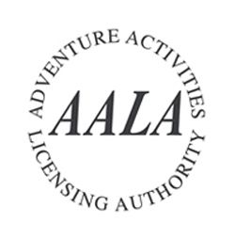

Insurance

The Conway Centre is covered by the Insurance of Edsential, who have comprehensive employer and public liability insurance at a value of £20 million. We do not provide personal accident or cancellation insurance.

Staff Competencies

All staff hold either the relevant NGB (National Governing Body) qualifications for their roles or have been assessed as competent by an appropriately qualified and experienced person.



https://www.adventuremark.co.uk/

**Emergency Procedures**

**Duty Staff** – We have a duty staff member on call 24hrs a day while we have groups in residence. The number to contact and where to find the duty staff member will be explained to you on arrival at centre.

**First Aid** – All duty staff and activity delivery staff hold a first aid qualification.

**Local Hospitals** – In the event of an emergency where a visitor may need to attend hospital, we can and will assist where possible in calling a local taxi company and provide you with directions accordingly. Some groups opt to bring a vehicle with them for any such emergencies.

**Anglesey** – Nearest hospital is in Bangor, Ysbyty Gwynedd, with an A&E department.

Ysbyty Gwynedd, Penrhosgarnedd, Bangor, Gwynedd, LL57 2PW

Tel: [01248 384 384](tel:+441248384384)

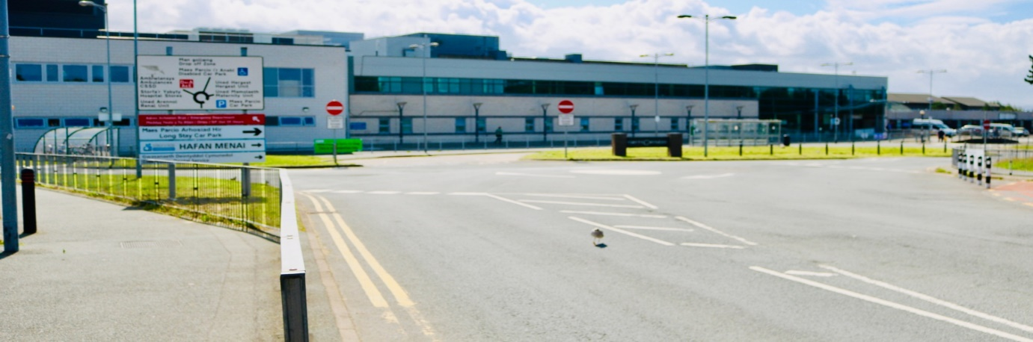

**Cheshire** – Nearest hospital is Leighton Hospital with an A&E department.

Middlewich Road, Crew, Cheshire, CW1 4QJ

Tel: 01270255141

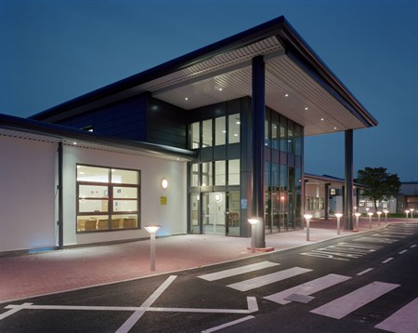

**Critical Incidents** – We have comprehensive procedures in place for dealing with any critical incident should one arise while your group is in residence so please rest assured all possibilities have been considered and appropriate emergency plans put in place.

**Parental Contact** – We recommend all groups bring a duty phone with them, to allow parents of any participants to contact the school/group leaders directly should they need to during your stay on centre. If for any reason the parent is unable to get hold of the group leader via this direct duty phone they may call the centre and relay a message. However, the centre cannot take any responsibility for any delay in a messages being relayed, which is why we always advise parents have a direct duty contact numbers for the main group leader responsible for their child during the visit.

Anglesey – 01248 546021

Cheshire – 01829 770223

**Booking Timeline**

**CONFIRMED BOOKING DATES**

Once you have signed and returned your Booking Confirmation Agreement to us, we will process your booking as confirmed and issue a part for full payment invoice accordingly.

* Less than 120 Days Prior to Arrival Date – Full Payment will be invoiced.
* More than 120 Days prior to Arrival Date – 30% Deposit Payment will be invoiced.
* Once the invoice is issued you have 30 days from date of issue to make payment.

**150 DAYS PRIOR TO ARRIVAL DATE**

* Initial planning and programming discussions will start to take place to initiate draft plans for you visit with us. Please do inform us of participant and staff numbers at your earliest opportunity and keep us updated if those numbers change.
* This is an important stage to make us aware of anything significant we may need to be aware of when planning for your visit. Accessibility/medical concerns within your group, key aims and objectives, etc.

**120 DAYS PRIOR TO ARRIVAL DATE**

* **Final Student and Staff Numbers are due** - We require final accurate numbers due to be attending 120 days prior to arrival so we can adequately and appropriately plan and prepare for your arrival and stay with us. We have hundreds of guests attend week on week, so require accurate information to plan staffing, housekeeping, catering provision, etc. Course details form can be found in appendix 1.
* **Balance Invoice Issued** – We will issue your remaining balance invoice 120 days prior to your arrival date, therefore to avoid an inaccurate invoice, we require you to provide final numbers no later than 120 days prior to arrival date. Once the invoice is issued you have 30 days from date of issue to make payment (90 days prior to arrival)
* **Accommodation Plan & Room Lists Issued** – You will be sent your accommodation plan along with room lists to be completed and returned by 60 days prior to arrival. For operational reasons accommodation is only finalised once we know your final numbers. Room List templates and PEEP templates can be found in appendix 2&3.
* **Programme, Group & Medical Lists Issued** – You will be sent your final programme along with activity group lists to be completed and returned by 60 days prior to arrival**.** Group List templates can be found I appendix 4
* **Dietary Details Form Issued** – You will be sent a dietary form to be completed and returned by 60 days prior to arrival. Dietary Details form can be found in appendix 5.

**60 DAYS PRIOR TO ARRIVAL DATE**

* **Accommodation Room Lists Due**
* **Groups Lists with Medical Details Due**
* **Dietary Details Due** – Having these details provided at this stage is vital for planning and ordering purposes. If we are unaware of dietary needs or only advised of them at short notice we may unfortunately not be in a position to deliver as we would have hope to.

**MORNING OF ARRIVAL DAY**

* **Wellbeing phone call** – Before you set-off on route to us we ask that a staff member within your group (or school/organisation office) give the centre a call to advise us that you’re on your way and when to expect your arrival. We also advise the main Course Leader/Booking Lead have the centre number with then while in transit in case they incur any delays.

If you have any further questions which have not been covered in this course leader pack, please do get in touch with us directly to discuss. We look forward to welcoming you and your group to the Conway Centres!!

Kind Regards

Conway Centres Guest Experience Team!!

The Conway Centres CCTV update

Dear school,

We would like to inform you ahead of your next visit to The Conway Centre Anglesey that during the period of closure we sustained due to Covid-19 we installed three CCTV cameras on the external areas of our building in the main reception area.

These cameras were installed as a security measure during periods we had no one working on site to help protect the building.

Ahead of schools returning to the site and as we have members of staff present at all times schools are on site, whilst the CCTV cameras are still in place, we would like to let you know that the cameras have been disconnected and will not be recording any footage during your visit and the cameras will only be switched on in future during periods where no schools or members of our team are on site.

Should our policy change on this matter where we have our CCTV cameras on during your visit, we will notify you of this in advance and any reasons for this.

Should you have any questions in relation to this please let us know.

Kind Regards

Nick McCavish

Head of Centres