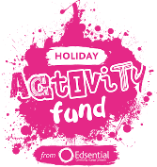
HAF – Case Study

Name of Organisation:
Date of provision:
Intro:

Issues:

Barriers overcome:

Impacts:

5 top tips for other providers:

Photo/video request (optional)
If you have 2 or 3 photos or a video link that you could share that brings your case study to life, please share.
If you are including pictures/video, please ensure you have photo permissions.
'Check your EEQU for parental permission if you are unsure'

